# **Screenshot App User Guide**

## **Overview:**

Welcome to the Screenshot App! This application allows you to easily capture screenshots, preview them, and interact with an API using the captured images.

## **Configuration:**

Follow these steps to configure or make use of the Screenshot App:

1. Launch the Screenshot App by clicking on the "**main.exe**" file, should be of type Application.

Choose the file regarding the operating system you are using.

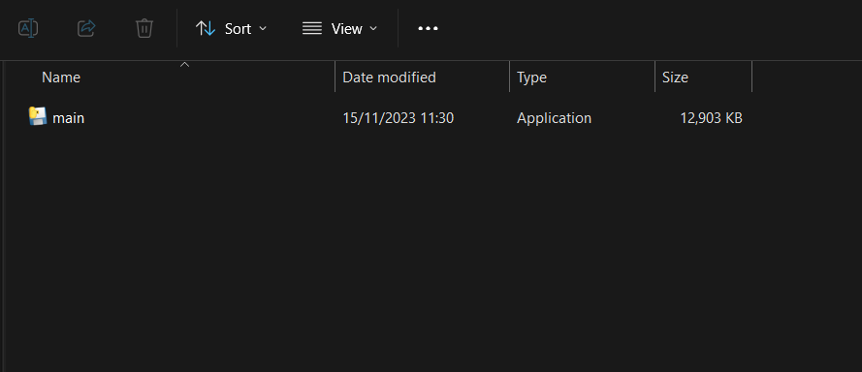

2. Direct to your screen destination where you want the screenshot of.

3. Taking a Screenshot: >Click on the "**Take Screenshot**" button<

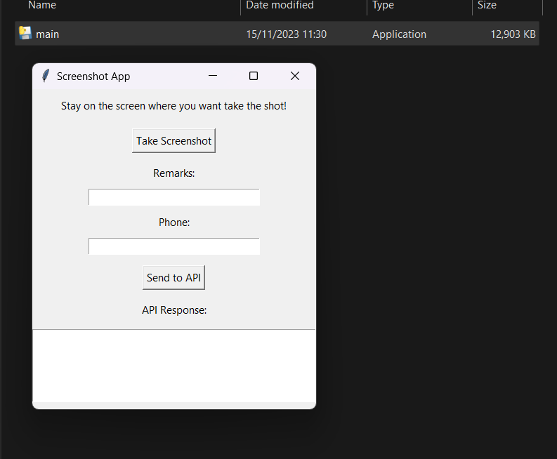



While you have clicked, the window is minimized and within 2 seconds the app captures and preview it.

And the app window is maximized back.

The images can be viewed in the current working directory where the app is saved; .\assets\images\

Note: The directory is created by the app, if it does not exist.

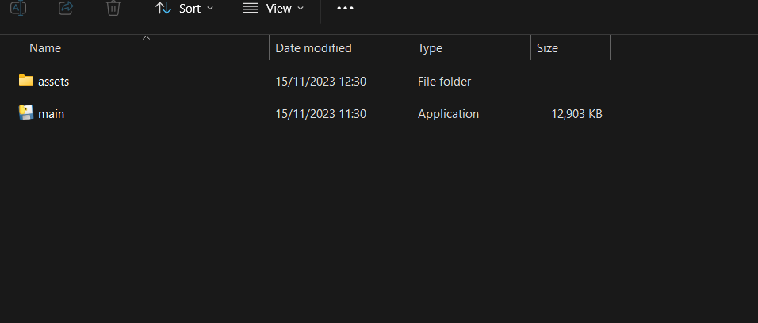

4. Next step is to fill in the required fields; remarks and phone



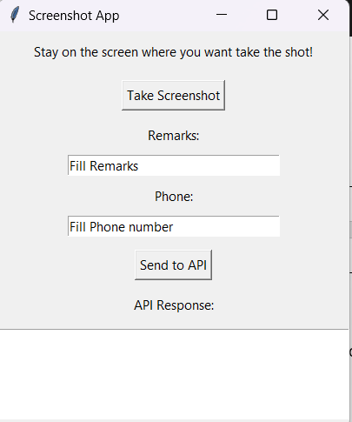

5. Clicking on Send to Api button, the image, remarks and phone data are sent to the endpoint.





6. Finally, you will receive a response from the Api in the Api Response Box.

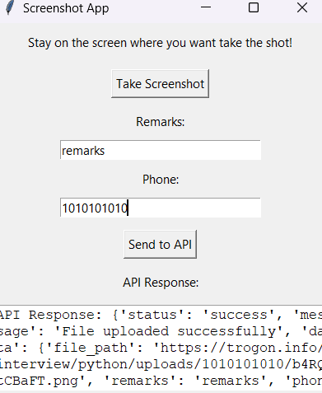



You will get the status as Success if the request has a 200-status code.

Happy Trailing!

Thank you for using the Screenshot App!